VOLUNTEER WAIVER FORM (VWF)

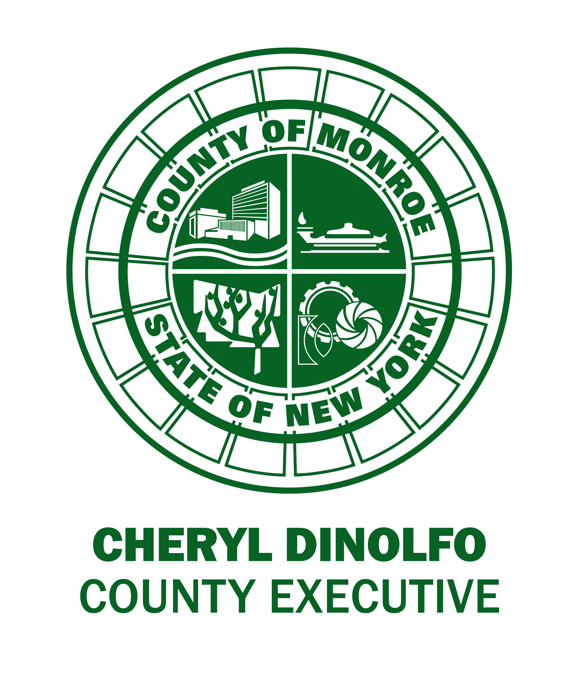

EACH VOLUNTEER MUST SUBMIT THIS FORM IN ORDER TO PARTICIPATE IN PICK UP THE PARKS (PUTP). Exception: You may fill out one form for you, your spouse, and/or multiple children/dependents. Please return this form by e-mail to coreybryant@monroecounty.gov, by US Mail or in person to 171 Reservoir Avenue, Rochester, NY, 14620, or by fax to 585-753-7281. You can also turn in this form at a PUTP Meet-Up Site. Please visit www.monroecounty.gov/parks/pickuptheparks.

Full Name: ___________________________________________ Phone: _______________________
Additional Family Members Names: ______________________________________________________
____________________________________________________________________________________
____________________________________________________________________________________
Address: ___________________________________________________________________________ ____________________________________________________________________________________
E-mail address: ______________________________________________________________________
Are you over age 18? _____ yes _____ no
Organization you represent (optional): ____________________________________________________
Emergency Contact Information
Name / Phone # / Any other relevant info: ________________________________________________ ____________________________________________________________________________________
NOTICE TO VOLUNTEER & AGREEMENT BY VOLUNTEER

I understand that I am not an employee of Monroe County (the “County”) and will not receive payment for my volunteer services. I will not represent myself as an employee of the County and understand that as a volunteer, I am not covered by the Workers’ Compensation Laws of New York State.

As a volunteer I agree to take full responsibility for my own actions, safety and welfare. I agree to release, indemnify and save harmless the County, its officers, officials, agents, employees, successors and assigns, from and against any and all liabilities, actions and causes of action which may arise, directly or indirectly from my participation as a volunteer.

I further understand that as a volunteer I am not allowed to operate any power equipment, drive County vehicles, handle County funds, supervise County employees, provide “life guarding” services or use/handle pesticides, herbicides or other hazardous chemicals. Exceptions to these restrictions must be approved in writing by the Director of Parks.

I declare that all the information provided on this application is true, and I understand that any falsifications or misrepresentation may result in my termination from the County’s volunteer program.

I give permission for my image to be used for Monroe County Parks’ publicity and Pick Up the Parks publicity. I understand that Park staff and volunteers may be photographing individuals and groups during the cleanup.

Applicant Signature: ______________________________________________________________

Date: ________________________________________
Parent/Guardian Signature if Applicant is under 18: _________________________________________

Parent/Guardian Name (Print): __________________________________________________________

